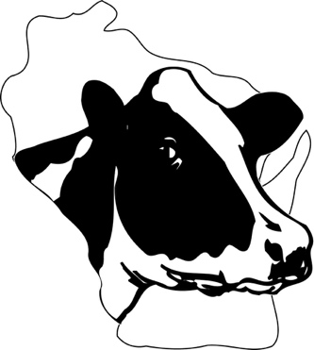
2023 WISCONSIN HOLSTEIN
JUNIOR FARM TOUR AWARD
sponsored by
Wisconsin Junior Holstein Association
Youth receive this award to be recognized for their enthusiasm and excitement about their future in the Holstein industry, as reported in this application.
Requirements:
- Applicant must be 16 years of age and not have reached their twenty-first birthday by January 1st of the year the Farm Tour Award is to be taken.
- Applicant must be a member of the state Holstein Junior Association by August 15th to be eligible.
- Applicants may go on the Farm Tour Award trip more than once in their Junior Holstein membership, however consideration will be given first to those that have never attended.
- The Farm Tour Award trip is tentatively scheduled for the weekend of March 23-24, 2024 (subject to change based on other spring event and selected participants’ schedules), with the area to visit to be determined.
Junior members who are state winners will be given a two-day trip to visit Wisconsin Holstein herds and other points of interest. Expenses paid by the Wisconsin Junior Holstein Association.

Personal Data:

Name: ________________________________________________________ Age (1-1-2024) ______________

Address ___________________________________________________ City, Zip________________________

Email___________________________________________

County _________________________________________ Telephone ______________________

Name of Parent or Guardian ____________________________________________________________________

Name of High School or College ________________________________________________________________

Present grade or year of school ____________________

Name of hometown newspaper _____________________________________________________

Email
Address ________________________________________________________________________
City, Zip ________________________________________________________________________

Applicant’s Signature ________________________ Date _________________

_____________________________________________________________ Date _________________
Signature of County Holstein Leader &/or County or State Board Member

Essay Question: Please answer the following on a separate sheet of paper, in one page or less.
Q: Indicate the type of dairy operations you would like to see and list three (3) things you hope to gain from this farm tour trip.

WI Holstein, 902 Eighth Ave, Baraboo, WI 53913 or email to wisholsteins@gmail.com
Due November 10, 2024 to the WHA office

