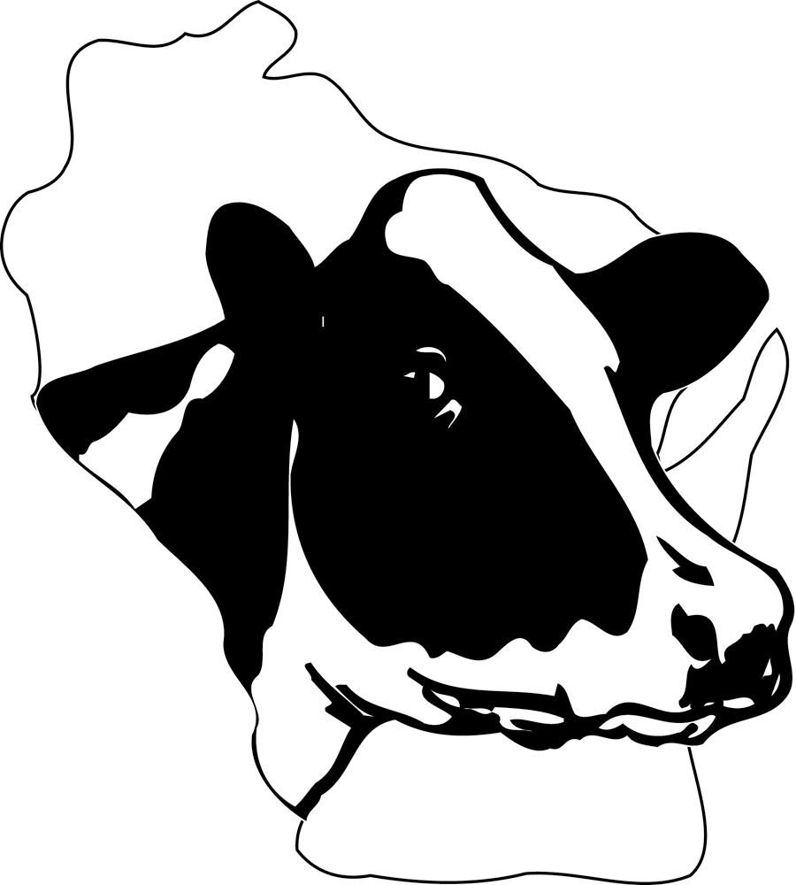

WISCONSIN HOLSTEIN

DISTINGUISHED YOUNG
HOLSTEIN BREEDER

Personal Information:

Name(s): ___________________________________________ Age(s): ______ as of (date)_________

Address: ____________________________________________________________________________

Town: _____________________________ State: _______ Zip: __________ County: _____________

Phone: ____________________________ Fax: ______________________ E-Mail: _______________

Farm Name: _________________________________ Prefix: __________________________________

Children with Age: ____________________________________________________________________

____________________________________________________________________________________

____________________________________________________________________________________

The following thoughts and records are those of the applicant and are true to the best of his/her knowledge.

Signature Date

Part One - Community Activities (10 pts.): List and discuss your community and dairy involvement. (Organization, position held, recognition received and years served) How do you plan to make a difference in the future? (Please limit to one page and if pictures and/or news releases are included, please limit to two additional pages totaling a possible three pages)

WISCONSIN HOLSTEIN DISTINGUISHED YOUNG BREEDER

AWARD FORM
Page 2

Part Two – Herd Status (45 pts.)
Herd Statistics: List the herd information that reflects the statistics of your herd at the age you assumed ownership and management responsibilities. Also list your current information and your 3-5 year goals.
When you assumed Current 3-5 Year
Ownership Level Goal
1. Herd Size:
87-100% RHA Cows
< 87% RHA Cows
Purebreds, not Holstein
Other

2. Rolling Herd Average: Number of years on test: __________
When you assumed Current 3-5 Year
Ownership Level Goal
Lbs. Milk
Lbs. Fat
Lbs. True Protein
Times milked per day
TriStar Enrollment
(Custom, Deluxe, Premier)

3. Herd Classification: Number of years herd classified: ___________
When you assumed Current 3-5 Year
Ownership Level Goal
# Cows
BAA
# Cows – Excellent
Very Good
Good Plus
Good
Fair
Poor

4. Herd Recognitions # of Years
Progressive Breeders Registry
Progressive Genetic Herd Award

5. Individual Cow Recognition # Earned
Gold Medal Dam
Dam of Merit
State & National Leader List
Lifetime Production (>200,000)
# of Animals
6. Cows on current Locator List
Bulls sold to A.I.
State Show Winners
National Show Winners
WI Top Performer

WISCONSIN HOLSTEIN DISTINGUISHED YOUNG BREEDER

AWARD FORM
Page 3

Part Three – Essay Questions (45 pts.) Maximum 500 words per question

- Explain how you originally acquired your herd and how has your investment in registered Holsteins been beneficial? What impact will Registered Holsteins have on your future?

- Discuss a management practice or practices (nutrition, housing, herd health, milk quality, or reproductive management are possible areas), where you have made great strides to improve your herd’s performance.

- As a Registered Holstein Breeder what herd improvement or marketing programs have been most beneficial for developing and promoting your herd?

- What traits or cow families in your herd do you see as most promising for your herd’s future?

Due in WHA office by November 10
Mail to: WHA, 902 8th Ave, Baraboo, WI 53913

Nominee(s) must be between the ages of 21 and 40 (as of January 1 of the upcoming year) and must be a member of the Wisconsin Holstein Association and the Holstein Association USA, Inc. Applicants applying as a couple or as business partners must all meet the age requirements. Herd ownership and/or management responsibility are required, and the herd they manage must be on DHIA test. Applicants may update their application annually. Applications not selected will be retained for the next two years for consideration for this recognition if still eligible.

