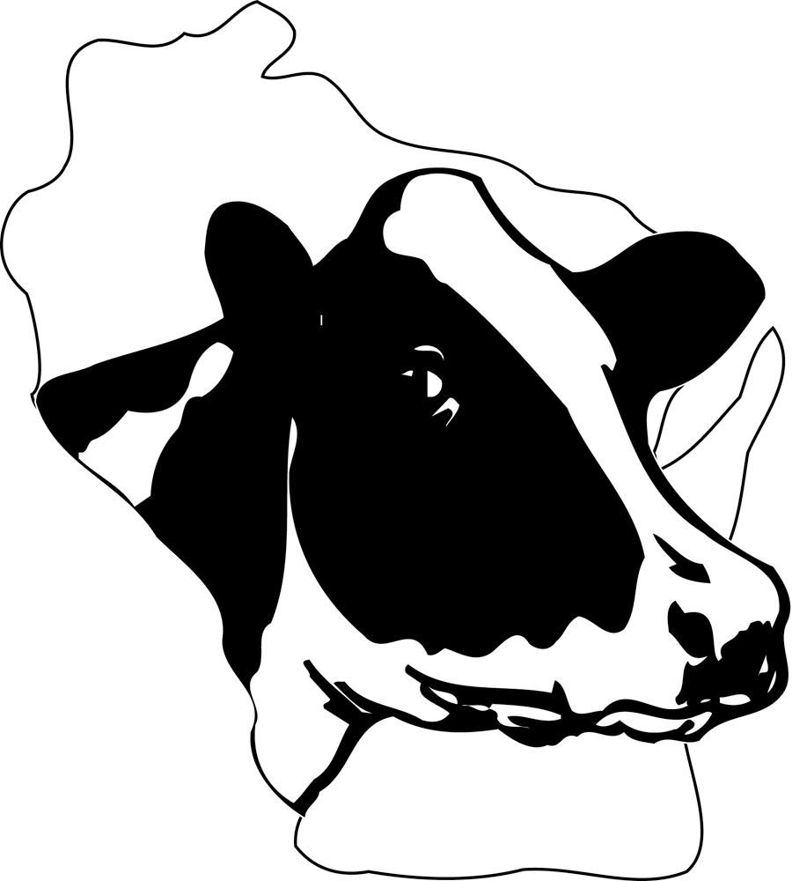
2023 Wisconsin Holstein
Distinguished Junior Member Award

Award form submission checklist:

____ 1. Application is a stapled document with no binder, fillers or extra pages, printed on plain bond paper. NO CARDSTOCK. OR a PDF of 10MB or less that will be emailed to wisholsteins@gmail.com. Please submit your application as one full document. Applications submitted as separate pieces will be returned and not considered “on time” until submitted correctly.

____ 2. 100-word biography included for press releases if selected as an award recipient. Biographies over 100 words will be edited to fit the word limit and may not include all the info you want, so please review your biography carefully.

____ 3. High resolution photo of applicant is included that can be scanned if selected as an award recipient or emailed to wisholsteins@gmail.com

____ 4. Personal summary form is complete with three required signatures

***If any of these requirements are not met, the award form will be considered incomplete and not submitted to the judging panel.***

Forms must be IN OFFICE by Monday, September 25, 2023.
PDF submissions of the full application will be accepted by email to wisholsteins@gmail.com. It is the applicant’s responsibility to verify that all sections of the application are included.

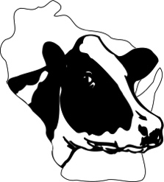
2023 Wisconsin Holstein
Distinguished Junior Member Award

The Wisconsin Junior Holstein Association’s Distinguished Junior Member (DJM) recognition is designed to reward youth who demonstrate a firsthand working knowledge of the dairy industry. Any junior member of the Wisconsin Holstein Association and Holstein Association USA, Inc., who has been enrolled in dairy project work with Holsteins, is eligible to compete in this contest.

Eligibility
Any Wisconsin Junior Holstein member that has not reached their 21st birthday, as of January 1, 2024, is eligible to participate in the state and national contest. Applicants must be a junior member of the Wisconsin and National Holstein Associations by August 15, 2023.

Interviews for Wisconsin Outstanding Holstein Boy and Girl will be held at the Wisconsin Junior Holstein Convention in December. If chosen for an interview, candidates must bring along a 1-page resume for the judges to review. Interviews take precedence over other Junior Convention activities.

The National Wisconsin DJM Representatives will be chosen through the interview process. National DJM applicants must not have reached their 21st birthday by January 1 in the year of recognition. All DJM recipients who are in their last year of eligibility and rank in the top 10 based off of overall score as a DJM contestant will receive an interview at the Wisconsin Junior Holstein Convention to be considered as a National DJM Representative for Wisconsin.

Entry Requirements
Applications for this award should be prepared carefully, typed and present an accurate portrayal of the applicant and Registered Holsteins he or she works with.
- Application must be presented as an electronic PDF or a stapled document, printed on regular paper (no card stock or cover stock) – DO NOT send a binder with individual page protectors. The judges of this contest see a photocopy of the application only.
- Application text should be typed in legible, 12-point font, with one-inch margins throughout. A similar font style should be used throughout the application.
- Applications should not contain filler materials.
- Every application must include a photo and 100-word or less biography to be used in news releases if applicant is selected as a winner.

1. Personal Summary Form
Each form should include this page with applicant signature, signature of a parent and a signature of a County Holstein leader and/or County or State Holstein board member.

2. Resume
Resume should be single-spaced, no more than three pages in length. The resume should include various activities, achievements, awards and offices held, with years of involvement listed. This section should encompass all types of projects and activities: Holstein, 4-H, FFA, church, community, employment, and educational experience. Emphasis will be placed on Holstein and Association activities, however, it is still important for applicants to show they are well-rounded individuals.
3. Story of Junior Holstein Work
Story of Junior Holstein Work should be double-spaced and no more than six pages in length. Applicants should tell the story of their Junior Holstein careers, emphasizing involvement on their home farm, or other dairy/agricultural operations, including specific responsibilities. Applicants may want to include specific details about their farm, discuss how they became involved in the industry, current involvement in Junior Holstein and other dairy activities, and future plans and career goals.

4. Knowledge of Management Practices
A. Inventory of Project Animals
Inventory of project animals or Registered Holsteins owned should be no more than three pages in length. List managerial or ownership animals in a neat and concise fashion, including name, registration number, date of birth, sire, dam, classification score (if applicable) and estimated value. Leased and partnership animals should be listed under a separate heading. If applicant wishes to include animals they have owned but are no longer in the herd, those should also be listed under separate headings.

B. Breeding, Obtaining and Developing
Breeding, Obtaining and Developing should be double-spaced and no more than three pages in length. Describe your breeding program, including sire selection criteria and guidelines, breeding philosophy, cow families and herd development plans. Also discuss how your current herd was obtained and financed, and how your herd has grown and developed through the course of your Junior Holstein project.

C. Vaccination & Health Protocols
Vaccination and Health Protocols should be single-spaced and no more than one page in length. With the understanding that each farm is different, applicants are encouraged to summarize the health protocols for their herd or project animals, including any of the following: calfhood vaccinations, dehorning, tagging/identifying, vet checks, hoof trimming, breeding, calving treatments, etc.

5. Personal Views
Answers to the following questions should be included in application and must be no longer than one page in length each, double-spaced, using a 12-point font with one-inch margins. Each question should be answered on a separate page.
- The use of beef on dairy has become more widespread in recent years for dairy herds. If you were managing a herd’s reproductive program, would you incorporate any beef semen in the program? Why or why not?
- Labor has been recognized as one of the biggest concerns for dairy farmers. If you were a farm manager or owner, how would you address a labor shortage on your farm?
- What three skills have you developed through your Holstein project work that will benefit you later in life?

6. OPTIONAL – Introduction Video
Those that are eligible to be selected for National DJM Recognition are encouraged to include a one-minute introduction video, telling the judges more about you, your farm and activities. This will NOT be used to aid in the judging of the award form on the state level. It is intended to provide an opportunity for feedback before the national contest, in addition to encouraging filming during the summer/warm months.

Use the following guidelines when preparing videos to submit with your DJM entry portfolio. Applicants may seek advice on how to edit videos. However, professional editing services are not permitted.

When filming your video, here’s some advice to avoid problems that may have a negative impact on your final product:
- Film in an area with good lighting.
- Be very aware of background noises – vehicles, farm equipment, birds, etc. Avoid filming near roadways, in barnyards, or other areas where you are likely to incur a lot of background noise.
- Be very aware of wind noise – while you may not hear it while you’re filming, most video cameras are very sensitive to picking up wind noise, and it can completely ruin your video. The safest bet is to find an area where there is very little to no breeze, film inside or film on a very calm day. Almost nothing can be done in the editing process to remove wind noise.
- Speak loud and clear so the camera picks up your voice well and viewers won’t have to strain to listen. Remember, your voice competes with any background noise that may be present.
- Have fun and be creative! Use the video as an opportunity to showcase your personality to the judges and help them get to know you and what you’re passionate about. This will be the only “personal” contact they have with you in the semifinalist selection process. Use it to your advantage and make the most of it.

Save the video file in one of the following preferred formats: .mp4, .avi, .mov, or .mpg.

When burning a DVD from your computer, save it as a data disc, rather than creating a DVD movie with a title menu (such as what would be played in a DVD player). When the disc is inserted in a computer, a viewer should be able to open it, individually select the file and open it in a media player of choice, such as Windows Media Player, RealPlayer, or QuickTime.

Visit www.youtube.com/HolsteinUSA to see examples of videos done by past National Distinguished Junior Member applicants.

Scorecard
Entries for the Wisconsin Holstein DJM Award will be scored according to the following.

Criteria | Point Value
Resume: Participation, leadership and variety of interests and activities, demonstrated by involvement in Holstein, dairy/agricultural activities, school, community, and other activities | 25
Story of Junior Holstein Work: Junior members’ participation and experiences on dairy/agricultural operations and explanation of involvement in Junior Holstein work and activities | 25
Inventory, Breeding, Obtaining and Developing Registered Holsteins, Vaccination and Animal Health Protocols: List project animals or animals owned in a concise fashion. Presentation of herd management practices, reflecting applicant’s knowledge of animal husbandry practices, including breeding and managing profitable Registered Holsteins | 20
Personal Views: Responses to questions should reflect originality, depth of thought and accuracy in facts presented. Applicant should demonstrate their abilities as a knowledgeable, enthusiastic and positive advocate for the dairy industry | 25
Presentation: Applicant presents a professional appearing, neat, accurate, properly organized entry, following all instructions and no filler material, paying attention to avoid spelling and grammatical errors | 5

Deadline for Entries:
In the WHA office by Monday, September 25, 2023
Send to: Wisconsin Holstein Association, 902 Eighth Ave, Baraboo, WI 53913
or email wisholsteins@gmail.com

1. Personal Summary Form - DJM

Name: ___________________________________________________________________________

Birthdate:____________________________ Age as of January 1, 2024 _______________________

Address:______________________________________ City:______________________________

Zip Code:_______________ County:__________________________________________
Email:______________________________________ Phone:________________________

Parent or Guardian Name(s):________________________________________________________

Name and Ages of Brothers Name and Ages of Sisters

Grade in School:__________ Name of School: ______________________________________

Name and Address of Local Newspaper:
Name: ________________________________________________________________________
Email:
Street Address: __________________________________________________________________
City: _________________________________________State:_________Zip: ________________
Must submit a 100-word or less biography and photo for a news release for WHA to use if selected.

The thoughts and records are those of the applicant and are true to the best of my knowledge.
___________________
(Your signature) (Date)

I have read the enclosed records and to the best of my knowledge find these records correct.
___________________
(Signature of parent) (Date)

I have read the enclosed records and to the best of my knowledge find these records correct.
___________________
(Signature of a County Holstein Leader &/or County or State Board Member) (Date)

*I would like to be considered for the 2024 Junior Farm Trip ____ yes ____ no

